A PROJECT REPORT ON
4 bit ALU Design using Verilog

DEPARTMENT OF ELECTRONIC AND COMMUNICATION
SESSION 2026-2027

Babu Banarasi Das Northern Indian Institute of Technology,Lucknow

Submitted To: Submitted By:
Sumit Ranjan Anamika Trivedi

1. Introduction
An Arithmetic Logic Unit (ALU) is a digital circuit that performs mathematical and logical operations. It is a fundamental building block of CPUs, microcontrollers, and digital signal processors.
In this project, two 4-bit inputs (A and B) are provided to the ALU. A 3-bit selection line determines which operation is performed. The output is displayed on a 4-bit result bus along with a carry output.
2. Objectives of the Project
- To design a 4-bit ALU using Verilog HDL.
- To perform arithmetic and logical operations.
- To verify the functionality through simulation.
- To understand combinational logic design using HDL.

3. Block Diagram
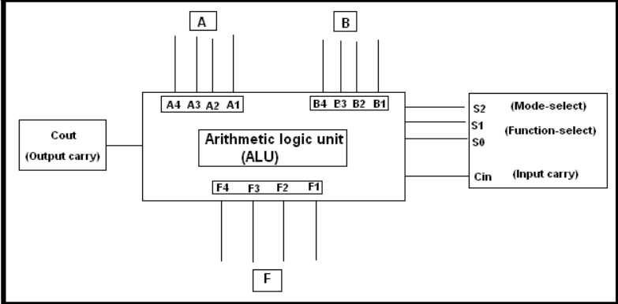

3. Hardware and Software Requirement
- Hardware
Computer/Laptop
- Software
Xilinx Vivado / ModelSim / Quartus Prime
Verilog HDL

4. Circuit Diagram
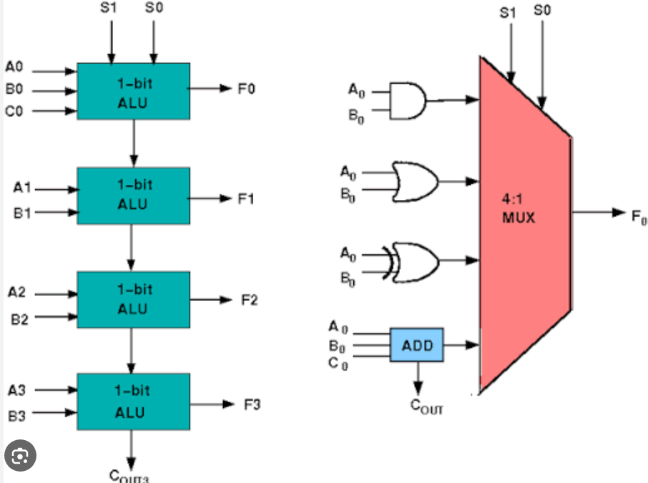

5.Operation performed
Select (Sel) Operation
000 Addition (A+B)
001 Subtraction (A−B)
010 AND
011 OR
100 XOR
101 NOR
110 Left Shift
111 Right Shift

6.Algorithm
- Read inputs A and B.
- Read the select signal (Sel).
- Compare Sel using a case statement.
- Perform the selected operation.
- Display the result.
- Repeat for different values of Sel.

7.Verilog Modules
- ALU Module
- Testbench Module

8.Stimulation Results
Example:-
A B Sel Operation Result
1010 0011 000 Addition 1101
1010 0011 001 Subtraction 0111
1010 0011 010 AND 0010
1010 0011 011 OR 1011
1010 0011 100 XOR 1001
1010 0011 101 NOR 0100
1010 0011 110 Left Shift 0100
- 0011 111 Right Shift 0101

9.Advantages

- Simple and efficient design.
- Easy to implement in FPGA.
- Fast operation.
- Reusable in larger digital systems

10.Applications
Central Processing Unit (CPU)
Microprocessors
Embedded Systems
Digital Signal Processing (DSP)
FPGA and ASIC Design

11. Future Scope
Design an 8-bit, 16-bit, or 32-bit ALU.
Add multiplication and division operations.
Include overflow and zero flags.
Integrate with a processor datapath.

12. Conclusion
The 4-bit ALU was successfully designed and implemented using Verilog HDL. The design performs arithmetic and logical operations correctly based on the select input. Simulation confirms the correctness of the design, making it suitable for FPGA implementation and educational purposes.

13. References
- M. Morris Mano, Digital Design, Pearson.
- Samir Palnitkar, Verilog HDL: A Guide to Digital Design and Synthesis.
- Douglas L. Perry, VHDL and Verilog HDL.
- Xilinx Vivado Design Suite User Guide.



